**SMART HOME AUTOMATION**

**Using Embedded System**

**By, Kaviselvan T**

**BE.ECE**

**Smart Home**

Welcome to my Smart Home Automation project, an innovative endeavour aimed at transforming traditional living spaces into intelligent, responsive, and energy efficient environments. In this project, I have harnessed the power of embedded systems to develop a comprehensive smart home solution that integrates a variety of sensors, microcontrollers, and actuators. This system is designed to provide enhanced convenience, safety, and efficiency through automated control of home appliances and monitoring systems.

The core of this project revolves around using Arduino boards to manage and control various aspects of home automation, including power supply management, automatic lighting, climate control, security systems, and more. By leveraging solar energy and advanced sensing technologies, this smart home system not only ensures uninterrupted power but also optimizes energy usage.

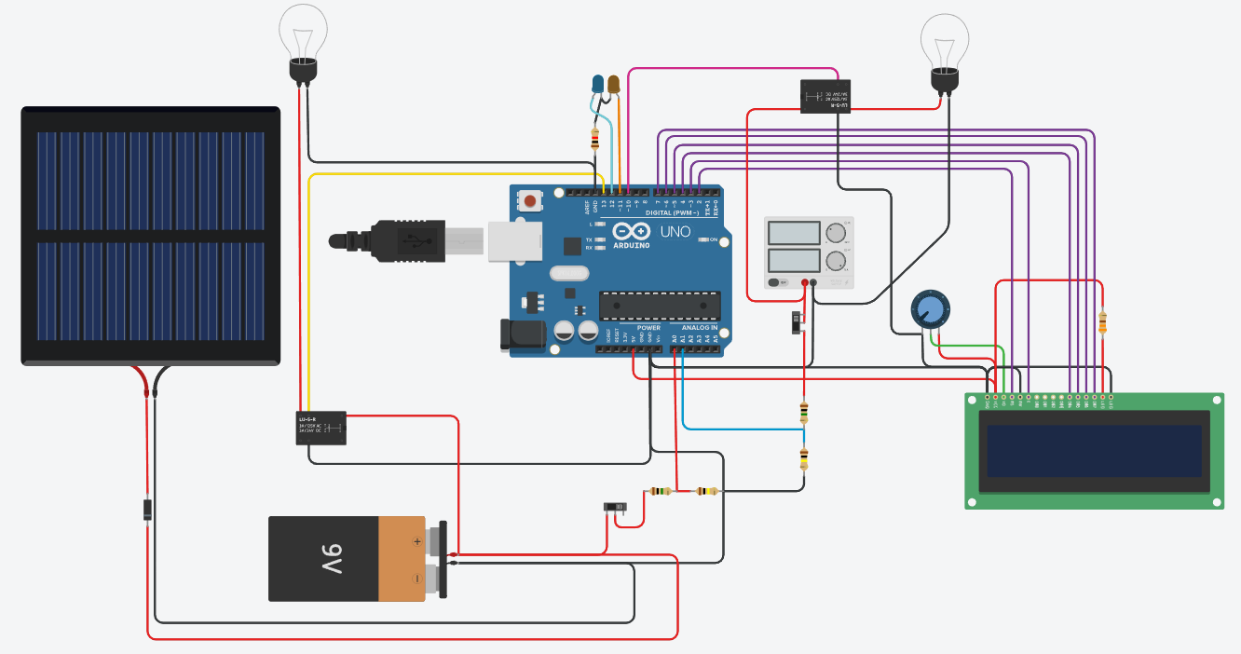**Power Supply for Home Automation**

In the smart home system, the Arduino board controls the overall power supply. The primary power source is connected to an external power supply. In the event of a power outage, solar-charged batteries are utilized to provide power to the home. Solar power is essential for charging the batteries, and they can also be charged using the primary power source from the home. The status of the battery power level and the transition between power sources is displayed and notified on a 2x16 display.

**Arduino Boards**

Arduino Uno boards used in this setup, each handling different aspects of the home automation system. This board is used to interconnect various embedded devices for sensing and actuation. This board is only for prototype purpose only. For this project we used three board to compensate all the devices.

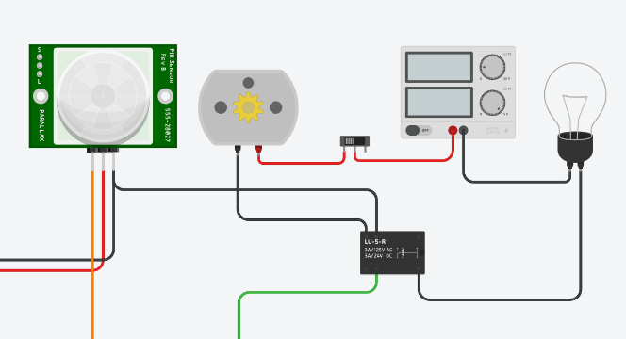**Automatic AC & Lighting**

The PIR sensor detects human motion and activates the air cooler and lighting in the room. It saves energy by automatically turning off the AC motor and lights when no one is present. It uses an external power supply.

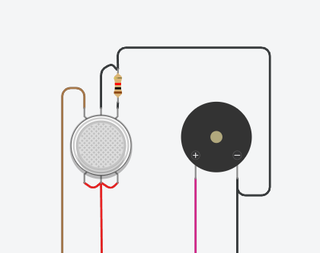

**Smoke Detector and Alarm System**

Gas sensors detect harmful gases and smoke in the home, and then send a signal through the alarm system to notify the residents.

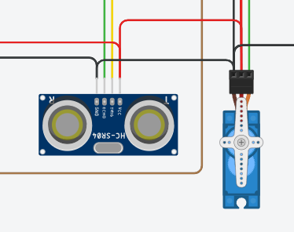

**Automatic Door Control**

The ultrasonic distance sensor and servo in the door are used to detect a person in front of the door and open it using the servo connected to the door hinges. After a certain amount of time, it will automatically close.

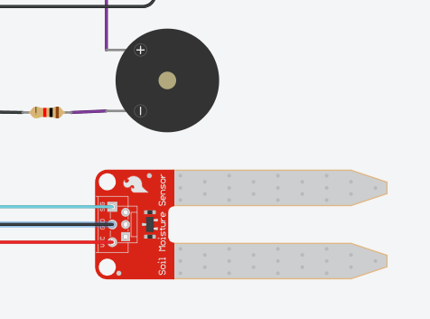**Rain Detection**

The rain sensor is placed in the environment to continuously monitor the surroundings. When rainwater droplets pass through the sensor, it closes the circuit to send a notification to the controller, which triggers the buzzer.

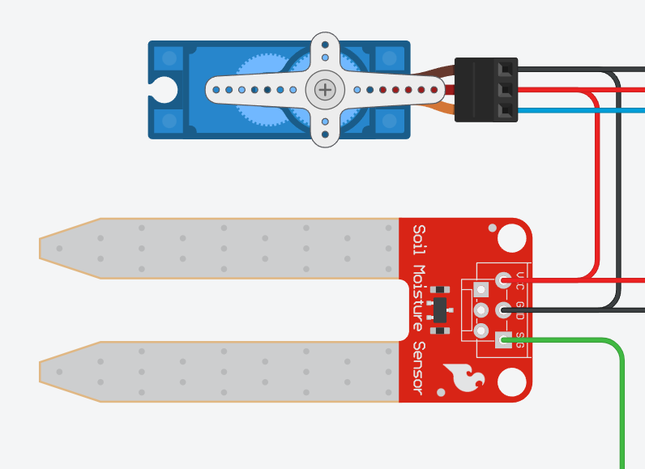**Moisture Monitor for Plants**

Soil moisture sensor is connected to the plant's field. The sensor continuously monitors the soil moisture scale. When the water moisture level decreases to a certain amount, the controller opens the water tap using a servo motor. the water moisture amount is reached, it turns off the tap.

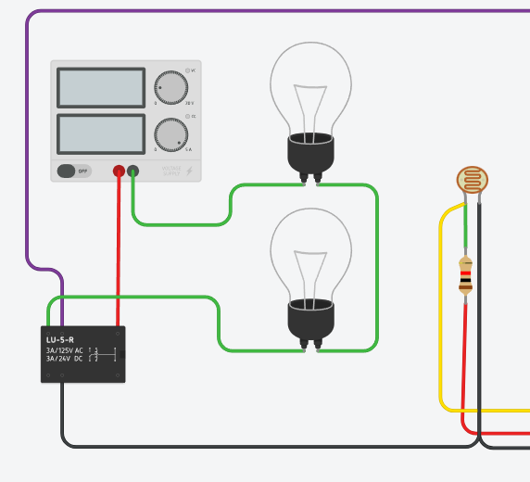**Automatic Lighting for Night**

The photoresistor sensor is placed here to observe the daylight and send the information to the controller. When the sensor detects a change in daylight conditions, the home lighting is turned on automatically.

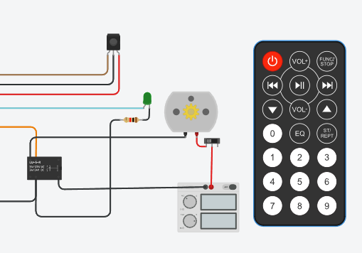**Manual Controls for Motors**

IR sensor and a remote are used to control the overall motor actions for different devices such as fans, AC, and water pumps. The entire system is set up for manual control. External power can be assigned to heavy-duty motors.

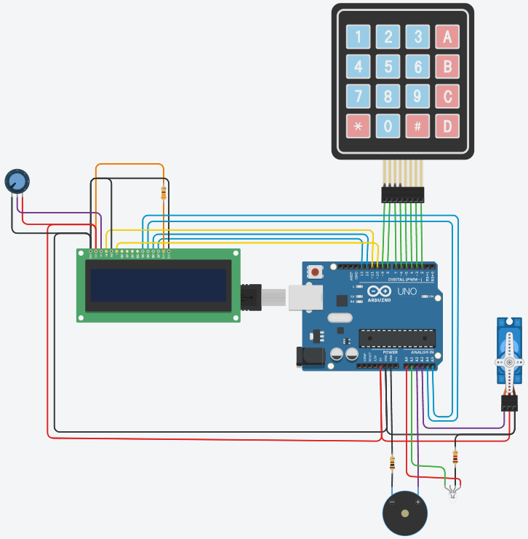

**Smart Lock**

When the numeric code is entered on the keyboard, it unlocks the passkey. The controller then operates the door servo to open when the passkey is entered correctly. If the wrong passkey is entered, the controller activates the buzzer.

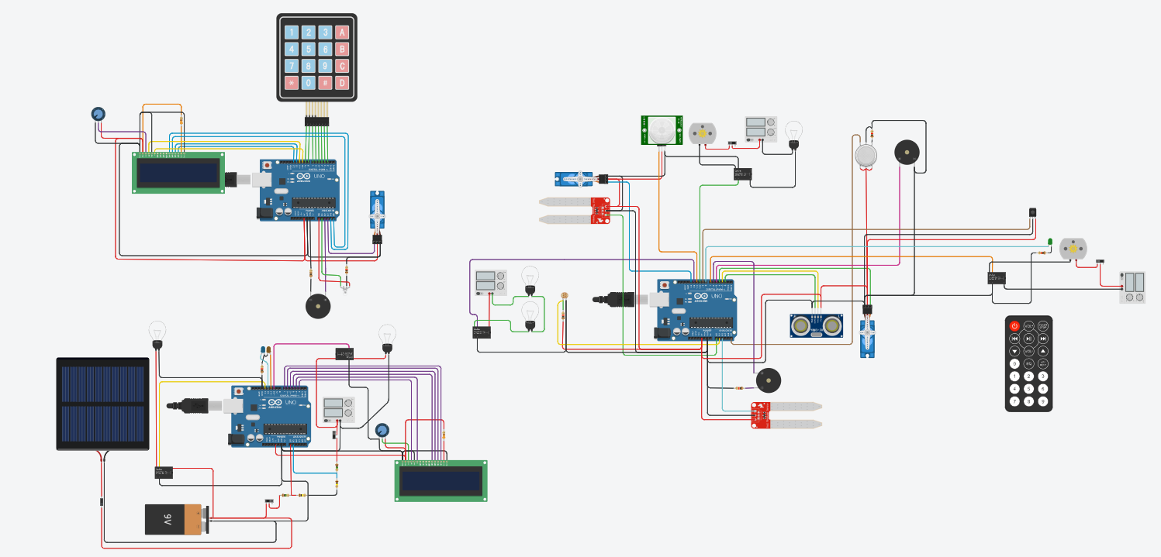**Program: Arduino UNO 1**

**2**

**3**

**1**

#include <Servo.h>

#include <IRremote.hpp>

//------------Door----------------//

Servo door_servo;

const int trigPin = 3;

const int echoPin = 2;

long duration;

int distance;

//----tap water for plant---------//

Servo tap;

int plantmoisture;

//---------Rain Alert-------------//

const int rainbuzzer = 6;

int rainsensor;

//---------FAN & LIGHT-------------//

int PIR_motion = 11;

int fan_light_switch = 10;

int pir_1;

//---------Gas Detection-------------//

int gas_buzzer = 5;

int gas_sensor = A5;

int gas_limit = 100;

//---------LDR lightning-------------//

int LDR = A1;

int ldr_light_switch = 12;

//---------IR remote control---------//

#define IR_RECEIVE_PIN 9

int LEDx_PIN = 8; //LED pin

int fan_switch_ = 7;//fan switch pin

void setup()

{

  Serial.begin(9600);

  //------------Door----------------//

  door_servo.attach(4); //servo pin 4

  pinMode(trigPin,OUTPUT);

  pinMode(echoPin,INPUT);

  //----tap water for plant---------//

  tap.attach(13); //servo-tap water

  //---------Rain Alert-------------//

  pinMode(rainbuzzer,OUTPUT); //signal to buzzer

  //---------FAN & LIGHT-------------//

  pinMode(PIR_motion,INPUT);

  pinMode(fan_light_switch,OUTPUT);//fan and light

  //---------Gas Detection-------------//

  pinMode(gas_buzzer,OUTPUT);//buzzer

  //---------LDR lightning-------------//

  pinMode(LDR,INPUT);

  pinMode(ldr_light_switch,OUTPUT);//light

  //---------IR remote control---------//

  IrReceiver.begin(IR_RECEIVE_PIN, ENABLE_LED_FEEDBACK);//IR signals

  pinMode(LEDx_PIN, OUTPUT); //LED pin

  pinMode(fan_switch_,OUTPUT); //fan pin

}

void loop()

{

  ////////////////////////////////////

  //------------Door----------------//

  digitalWrite(trigPin,LOW);//reset trig pin

  delayMicroseconds(2);

  digitalWrite(trigPin,HIGH);

  delayMicroseconds(10);

  digitalWrite(trigPin,LOW);

  duration = pulseIn(echoPin,HIGH);

  distance = (duration*0.034)/2; //constant=speed of sound 0.034

  //door servo

  if (distance<=150)

    {

    door_servo.write(90);

    Serial.print("|| Door Opened!  || Distance:");

    Serial.println(distance);

    Serial.print("\n");

  }

  else {

    door_servo.write(0);

    Serial.print("|| Door closed!  || Distance:");

    Serial.println(distance);

    Serial.print("\n");

  }

  ////////////////////////////////////

  //----tap water for plant---------//

  plantmoisture = analogRead(A0); //values 0-1023

  if (plantmoisture<=200)

  {

    tap.write(90);

    Serial.print("|| Plant Dried!!  || ");

    Serial.println(plantmoisture);

    Serial.print("\n");

  }

  else {

    tap.write(0);

  }

  ////////////////////////////////////

  //---------Rain Alert-------------//

  rainsensor = analogRead(A2); //values 0-1023

  if (rainsensor>=100)

  {

    tone(rainbuzzer,100);

    Serial.print("|| Raining!!  || ");

    Serial.println(rainsensor);

    Serial.print("\n");

  }

  else {

    noTone(rainbuzzer);

  }

  ////////////////////////////////////

  //---------FAN & LIGHT-------------//

  pir_1 = digitalRead(PIR_motion);

  if (pir_1 == HIGH)

  {

    digitalWrite(fan_light_switch,HIGH);

  }

  else {

    digitalWrite(fan_light_switch,LOW);

  }

  //---------Gas Detection-------------//

  int gas_val = analogRead(gas_sensor); //read sensor value

  if (gas_val > gas_limit)

    {

    tone(gas_buzzer, 600);

    Serial.print("|| Gas Sensor Value = ");

    Serial.print(gas_val);

    Serial.print("\n");

    }

  else {

    noTone(gas_buzzer);

  }

  ////////////////////////////////////

  //---------LDR lightning----------//

  int ldr_val = analogRead(LDR); //read sensor value

  if (ldr_val >= 500)

  {

    digitalWrite(ldr_light_switch,HIGH);

  }

  else {

    digitalWrite(ldr_light_switch,LOW);

  }

  Serial.print("|| LDR Sensor Value = ");

  Serial.print(ldr_val);

  Serial.print("\n ");

  ////////////////////////////////////

  //---------IR remote control---------//

  if (IrReceiver.decode()) {

    Serial.println(IrReceiver.decodedIRData.decodedRawData, HEX); // Print raw data

    IrReceiver.printIRResultShort(&Serial); // Print complete received data in one line

    IrReceiver.printIRSendUsage(&Serial);   // Print the statement required to send this data

    switch (IrReceiver.decodedIRData.command) {

      case 0x10: // press 1 to turn ON light

        digitalWrite(LEDx_PIN, HIGH);

        break;

      case 0xc: // press 0 to turn OFF light

        digitalWrite(LEDx_PIN, LOW);

        break;

      case 0x5: // press play to turn ON FAN

        digitalWrite(fan_switch_, HIGH);

        break;

      case 0x0: // press power key to turn OFF FAN

        digitalWrite(fan_switch_, LOW);

        break;

    }

    IrReceiver.resume(); // Prepare to receive next IR signal

  }

  ////////////////////////////////////

  delay(10);

}

**Program: Arduino UNO 2**

#include <Keypad.h>

#include <LiquidCrystal.h>

#include <Servo.h>

//-----------------------keypad-----------------------------//

const byte ROWS = 4;//rows in the keypad

const byte COLS = 4;//columns in the keypad

char hexaKeys[ROWS][COLS] = {

  {'1', '2', '3', 'A'},

  {'4', '5', '6', 'B'},

  {'7', '8', '9', 'C'},

  {'*', '0', '#', 'D'}

};//key layout

byte rowPins[ROWS] = {9, 8, 7, 6};//pins connected to rows

byte colPins[COLS] = {5, 4, 3, 2};//pins connected to columns

Keypad customKeypad = Keypad(makeKeymap(hexaKeys), rowPins, colPins, ROWS, COLS);

//-------------------------LCD-------------------------------//

LiquidCrystal lcd(11, 10, A4, A5, 12, 13);//(rs, enable, d4, d5, d6, d7)

//-------------------------Password-------------------------------//

#define Password_Length 5

char Data[Password_Length];

char Passkey[Password_Length] = "1234";

byte data_count = 0;//passkey_count = 0;

char customKey;

//--------------door action---------//

int G_doorled = A1;//green led

int R_doorled = A0;//red led

int door_buzzer1 = A2;//buzzer

Servo door_ser; //door servo

void setup(){

  lcd.begin(16, 2);// set up the LCD's number of columns and rows:

  lcd.clear();// Clears the LCD screen

  pinMode(G_doorled, OUTPUT);

  pinMode(G_doorled, OUTPUT);

  pinMode(door_buzzer1,OUTPUT);//buzzer

  door_ser.attach(A3);//door servo

}

void loop(){

  lcd.setCursor(0,0);

  lcd.print("Enter Password:");

  customKey = customKeypad.getKey();

  if (customKey){

    Data[data_count] = customKey;//array Data[...]

    lcd.setCursor(data_count,1);//display data_count'th column & 1'th row

    lcd.print(Data[data_count]);

    data_count++;

    }

  if(data_count == Password_Length-1){

    lcd.clear();

    if(!strcmp(Data, Passkey)){ //Data & Master comparing

      lcd.print("Correct");

      digitalWrite(G_doorled, HIGH);

      door_ser.write(90);//door open

      delay(10000);

      digitalWrite(G_doorled, LOW);

      door_ser.write(0);//door close

      }

    else{

      lcd.print("Incorrect");

      digitalWrite(R_doorled, HIGH);

      tone(door_buzzer1,600);//buzzer if wrong

      delay(5000);

      }

    lcd.clear();

    clearData();//clear data from data_count(from void clearData())

  }

}

void clearData(){

  while(data_count !=0){

    Data[data_count--] = 0;

  }

  return;

}

**Program: Arduino UNO 3**

#include <LiquidCrystal.h>

LiquidCrystal lcd(2, 3, 4, 5, 6, 7);//(rs, enable, d4, d5, d6, d7)

int led_pin_Bon = 12;//battery

int led_pin_PSon = 11;//power supply

int power_switch_Bt = 13;//battery load's switch

int power_switch_Ps = 10;//power supply load's switch

void setup(){

  lcd.begin(16, 2);//LCD's number of columns and rows

  lcd.clear();//Clears LCD screen

  pinMode(led_pin_Bon,OUTPUT);//power from battery

  pinMode(led_pin_PSon,OUTPUT);//power from power supply

  pinMode(power_switch_Bt,OUTPUT);//battery to load switch

  pinMode(power_switch_Ps,OUTPUT);//power supply to load switch

  //initially

  digitalWrite(led_pin_PSon, LOW);//orange led off

  digitalWrite(power_switch_Ps,LOW);//power supply OFF

  digitalWrite(led_pin_Bon, LOW);//blue led off

  digitalWrite(power_switch_Bt,LOW);//battery OFF

}

void loop()

{

  switchPower();

}

 void switchPower()

{

  //POWER SUPPLY

  int sensorValue_B = analogRead(A0); //read the A0 pin value

  float voltage_B = sensorValue_B * (5.00 / 1023.00) * 11; //convert the value to a true voltage.(for 10v)

  lcd.setCursor(0,0);

  lcd.print("BT.voltage=");

  lcd.print(int round(voltage_B)); //print the battery voltage to LCD

  lcd.print(" V");

  //BATTERY

  int sensorValue_PS = analogRead(A1); //read the A0 pin value

  float voltage_PS = sensorValue_PS * (5.00 / 1023.00) * 11; //convert the value to a true voltage.(for 9v)

  lcd.setCursor(0,1);

  lcd.print("PS.voltage=");

  lcd.print(int round(voltage_PS)); //print the power supply voltage to LCD

  lcd.print(" V");

  //switch between battery and power supply

   //both are LOW-------------

   if ((voltage_B <= 5) && (voltage_PS <= 5))

   {

     digitalWrite(led_pin_PSon, LOW);//orange led off

     digitalWrite(power_switch_Ps,LOW);//power supply OFF

     digitalWrite(led_pin_Bon, LOW);//blue led off

     digitalWrite(power_switch_Bt,LOW);//battery OFF

     lcd.clear();

     lcd.print("NO POWER");//indicate no power

   }

   else if (voltage_PS <= 5 || voltage_B <= 5)

   {

     //battery power------------

     if (voltage_PS <= 5)

     {

       digitalWrite(led_pin_Bon, HIGH);//blue led

       digitalWrite(power_switch_Bt,HIGH);//battery to load

     }

     else

     {

       digitalWrite(led_pin_Bon, LOW);//blue led off

       digitalWrite(power_switch_Bt,LOW);//battery OFF

     }

     //power supply------------

     if (voltage_B <= 5)

     {

      digitalWrite(led_pin_PSon, HIGH);//orange led

      digitalWrite(power_switch_Ps,HIGH);//power supply to load

     }

     else

     {

       digitalWrite(led_pin_PSon, LOW); //orange led off

       digitalWrite(power_switch_Ps,LOW);//power supply OFF

     }

   }

   //both are HIGH------------

   if ((voltage_B > 5) && (voltage_PS > 5))

   {//connect to power supply

     digitalWrite(led_pin_PSon, HIGH);//orange led

     digitalWrite(power_switch_Ps,HIGH);//power supply to load

     digitalWrite(led_pin_Bon, LOW);//blue led off

     digitalWrite(power_switch_Bt,LOW);//battery OFF

   }

   delay(100);

}

**Components:**

|  |  |  |
| --- | --- | --- |
| Name | Quantity | Component |
| SERVOdoor, SERVOwater tap, SERVOmain door | 3 | Positional Micro Servo |
| SEN1, SEN2 | 2 | Soil Moisture Sensor |
| R1 | 1 | Photoresistor |
| R2, R4, R5, R3, R13, R14 | 6 | 1 kΩ Resistor |
| L1, L2, L5, L4, L3 | 5 | Light bulb |
| GAS1 | 1 | Gas Sensor |
| PIEZO1, PIEZO2, PIEZO3 | 3 | Piezo |
| SC1 | 1 | 5 V, 100 mA Solar Cell |
| P1, P2, P3 | 3 | 5 , 5 Power Supply |
| U2, U6 | 2 | LCD 16 x 2 |
| BAT2 | 1 | 9V Battery |
| K1, K2, K3, K4, K5 | 5 | Relay SPDT |
| M1, M2 | 2 | DC Motor |
| PIR1 | 1 | PIR Sensor |
| KEYPAD1 | 1 | Keypad 4x4 |
| U4 | 1 | IR sensor |
| S1, S2, S3, S4 | 4 | Slideswitch |
| U5, U1, U7 | 3 | Arduino Uno R3 |
| R6, R10 | 2 | 330 Ω Resistor |
| Rpot1 | 1 | 10 kΩ Potentiometer |
| R7 | 1 | 100 Ω Resistor |
| Rpot3 | 1 | 250 kΩ Potentiometer |
| R8, R12 | 2 | 1 MΩ Resistor |
| R9, R11 | 2 | 100 kΩ Resistor |
| P5 | 1 | 9 , 5 Power Supply |
| D2 | 1 | Diode |
| D3 | 1 | Green LED |
| DIST1 | 1 | Ultrasonic Distance Sensor (4-pin) |
| D1 | 1 | LED RGB |
| D4 | 1 | Orange LED |
| D5 | 1 | Blue LED |

**Conclusion**

This Smart Home Automation project demonstrates the potential of embedded systems to enhance the convenience, safety, and energy efficiency of modern homes. By integrating various sensors and automated controls, the system offers a sophisticated solution to everyday challenges in home management.